**INTRODUCTION**

* Main objective in development of this project is to make **New Linux** user feel more comfortable Web stack services without having Linux *command knowledge*.
* New Linux user don't have to panic to configure Web Stack Services manually. With *single click* you can setup and configure web services.
* Now New Linux user don’t have to search and learn on google ‘*how to install LEMP stack in Linux*’.

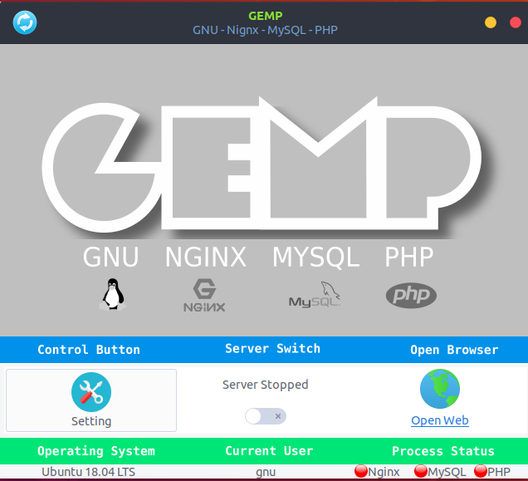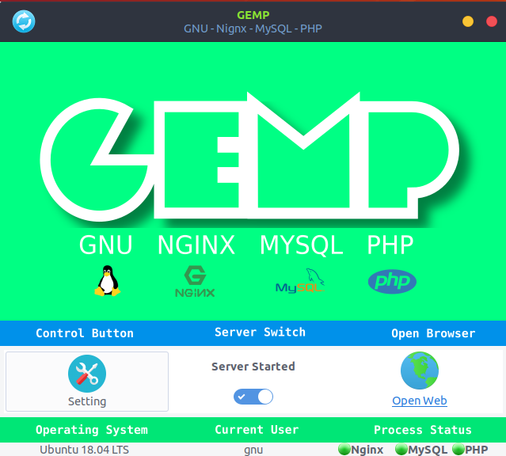**WHEN ALL SERVICES ON** **WHEN ALL SERVICES OFF**

**FEATURES**

1. **RELOAD:** With one click on reload button it will reload all the Stack services for you.
2. **SETTING:** Here you can configure all stack services with few click, no manually configure file editing needed.
3. **SERVER SWITCH:** With single click you can switch ON/OFF all server stack services.
4. **CURRENT OS:** This field will show your operating system name.
5. **CURRENT USER:** This field will show current your system current user.
6. **SERVICE INDICATOR:** These are the indicator of stack services. If is on then green light will glow up otherwise red will.
7. **OPEN WEB:** This will open current localhost web address with single click.

**SYSTEM ANALYSIS**

**DEFINITION OF SYSTEM ANALYSIS**

System analysis as "the process of studying a procedure or business in order to identify its goals and purposes and create systems and procedures that will achieve them in an efficient way". Another view sees systems analysis as a problem-solving technique that decomposes a system into its component pieces for the purpose of the studying how well those component parts work and interact to accomplish their purpose. Analysis and synthesis, as scientific methods, always go hand in hand; they complement one another. Every synthesis builds upon the results of a preceding analysis, and every analysis requires a subsequent synthesis in order to verify and correct its results.

The field of systems analysis relates closely to requirements analysis or to operations research. It is also "an explicit formal inquiry carried out to help a decision maker identify a better course of action and make a better decision than she might otherwise have made.

**IDENTIFICATION OF NEED**

When you asked to computerize a system, as a requirement of the data processing or the information need, it is necessary to analyze the system from different angles. While satisfying such need, the analysis of the system is the basic necessity for an efficient system design. The need for analysis stems from the following point of view.

**System Objective:** It is necessary to define the system objective(s).  Many a time, it is observed that the systems are historically in operation and have lost their main purpose of achievement of the objectives.  The users of the system and the personnel involved are not in a position to define the objective(s). Since you are going to develop a computer-based system, it is necessary to redefine or reset the objective(s) as a reference point in the context of the current business requirement.

**System Boundaries:**  It is necessary to establish the system boundaries which would define the scope and the coverage of the system.  This helps to sort out and understand the functional boundaries of the system, the department boundaries in the system, and the people involved in the system.  It also helps to identify the inputs and the outputs of the various sub-systems covering the entire system.

**System Importance:** It is necessary to understand the importance of the system in the organization.  This would throw more light on its utility and would help the designer to decide the design features of the system.  It would be possible then to position the system in relation to the other systems for deciding the design strategy and development.

**Nature of The System:** The analysis of the system will help the system designer to conclude whether the system is the closed type or open, and a deterministic or probabilistic.  Such an understanding of the system is necessary, prior to design the process to ensure the necessary design architecture.

**PRELIMINARY INVESTIGATION**

Role of the System as an Interface: The system, many times, acts as an interface to the other systems.  Hence through such an interface, it activates or promotes some changes in the other systems. It is necessary to understand the existing role of the system, as an interface, to safeguard the interests of the other systems. Any modifications or changes made should not affect the functioning or the objective of the other systems.

**FEASIBILITY STUDY**

**1. Technical feasibility:** This is concerned with specifying equipment and software that will successfully satisfy the user requirement.

During the analysis of technical feasibility of the system, it is considered that.

* It should produce service status correctly.
* It should produce output in a given time.
* It should configure correctly according to user input.
* All the configure file of services are working correctly.

This application is developed in **Python3** with **Gtk+3** and **json**. **Python3** is an interpreted high level language for general purpose use. **Gtk+3** or *Gimp Toolkit*, is a multi-platform toolkit for creatig graphical user interface. **Json** (*Javascript Object Notation*) is a lightweight data-interchange format. It is easy for human to read or write. It is easy for machines to parse or generate.

The project comes under the category of Server Tools. Hence we are using whole Web Service Stack like Nginx to manage http request, MySQL to handle Database management service, PHP is to handle back-end server site script.

**2. Operational Feasibility:** The project ‘GEMP’ offers a systematic operational feasibility keeping in mind for future needs.

The structure of the program is developed by keeping in mind for Open-source contributers all over the world so, its structure is entirely flexible, welcoming new changes without catastrophic failures. It is easy for a new users to access its source code, modify and redistribute it under **GPLv3** License policy.

**3. Economic Feasibility:** The project ‘**GEMP**’ is Open-source and comes under economically feasible projects as no funding is required in development and publishing process. Afterwards, the project will contribute by many Open-source contributer and make it more fast and secure with tweaking and bug fixing.

**ANALYSIS**

**DATA FLOW DIAGRAM**

A Data Flow Diagram (DFD) is a graphical representation of the "flow" of data through an Information System. A data flow diagram can also be used for the visualization of Data Processing. It is common practice for a designer to draw a context-level DFD first which shows the interaction between the system and outside entities. This context-level DFD is then "exploded" to show more detail of the system being modeled.

A DFD represents flow of data through a system. Data flow diagrams are commonly used during problem analysis. It views a system as a function that transforms the input into desired output. A DFD shows movement of data through the different transformations or processes in the system.

Dataflow diagrams can be used to provide the end user with a physical idea of where the data they input ultimately has an effect upon the structure of the whole system from order to dispatch to restock how any system is developed can be determined through a dataflow diagram. The appropriate register saved in database and maintained by appropriate authorities.

**Data Flow Diagram Notation**

.

1. Function
2. File/Database
3. Input/output
4. Flow

.

**DATA FLOW DIAGRAMS**

**0-LEVEL DFD**

**OPERATING**

**SYSTEM**

**User**

**PHP**

**MYSQL**

**NGINX**

**1-LEVEL DFD**

**Default**

**Configuration**

**file**

Send signal to Services and get back request respond.

Request to OS

**MYSQL**

**PHP**

**Nginx**

**User’s Conf.**

**file**

**User**

**Check**

**Conf. file**

RUN Application

Ask Super User Permission

**OPERATING SYSTEM**

**Configuration**

**file**

**loaded**

**Root User**

**Check**

**ER DIAGRAM**

An entity-relationship diagram (ERD) is a graphical representation of an information system that shows the relationship between people, objects, places, concepts or events within that system. An ERD is a data modelling technique that can help define business processes and can be used as the foundation for a relative database.

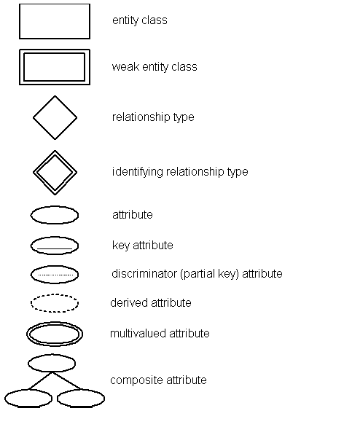

**HARDWARE AND SOFTWARE REQUIREMENT**

* **HARDWARE REQUIREMENTS**
* **Disk Space : 1** GB
* **Memory :** 256 MB minimum
* **Processer Speed :** Minimum 1.12Ghz
* **Processor :** Any standard x86, x64, ARM
* **Operation System : GNU/LINUX (Debian Based)**

**SOFTWARE REQUIREMENTS**

* WEB BROWSER
* INERNET CONNECTION
* **Dependencies:** Python 3.3, GtkToolkit, pyGtk, Gtk+3, PHP7.2-fpm, MySQL, NginX, gnome-utils, pip3, Adminer.

**VALIDATION CHECKS**

**Validation is an automatic computer check to ensure that the data entered is sensible and reasonable. It does not check the accuracy of data.**

For example, a secondary school student is likely to be aged between 11 and 16. The computer can be programmed only to accept numbers between 11 and 16. This is a**range** check.

However, this does not guarantee that the number typed in is correct. For example, a student's age might be 14, but if 11 is entered it will be valid but incorrect.

## **Types of validation**

There are a number of validation types that can be used to check the data that is being entered.

| **Validation type** | **How it works** | **Example usage** |
| --- | --- | --- |
| Check digit | the last one or two digits in a code are used to check the other digits are correct | bar code readers in supermarkets use check digits |
| Format check | checks the data is in the right format | a National Insurance number is in the form LL 99 99 99 L where L is any letter and 9 is any number |
| Length check | checks the data isn't too short or too long | a password which needs to be six letters long |
| Lookup table | looks up acceptable values in a table | there are only seven possible days of the week |
| Presence check | checks that data has been entered into a *field* | in most *databases* a *key field*cannot be left blank |
| Range check | checks that a value falls within the specified range | number of hours worked must be less than 50 and more than 0 |
| Spell check | looks up words in a dictionary | when word processing |

**FUTURE SCOPE**

1. Support other Linux Ditribution like: RatHat, CentOS, ArchOS.
2. Support multiple site request handling.
3. System notification tray.
4. Add more Dynamic DNS Clients.

**LIMITATION OF THIS PROJECT**

* Support only Debain Based Distros.
* Doesn’t work in Windows or Mac OS.
* Dependencies Needed to run this application.
* Many bugs are to be fixed.
* Many Features are to be added.